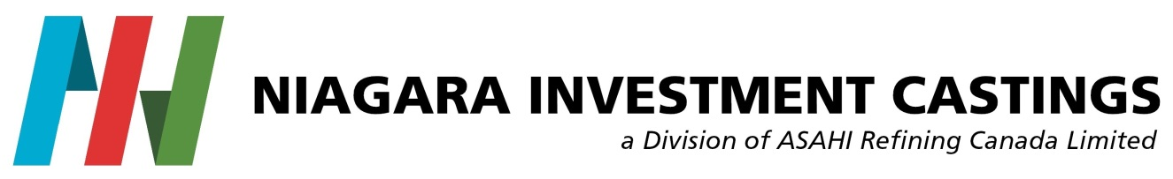
Accessibility for Ontarians with Disability (AODA)

CUSTOMER FEEDBACK FORM

Thank you for visiting Niagara Investment Castings. We value all of our customers, vendors, contractors and individuals with disability who enter our premises and strive to meet everyone’s needs.

Please tell us the date and time of your visit:

Did we respond to your customer services needs today? YES NO

Was our customer service provided to you in an accessible manner?

Yes Somewhat No (please explain below)

Please add any further comments you may have:

Contact Information (optional):

Thank you,

Niagara Investment Castings

